AWS DevOps Project for Static Website Deployment:
Project Summary for Recruitment Review
Project Overview
This project demonstrates the design and implementation of a complete CI/CD (Continuous Integration and Continuous Deployment) pipeline for deploying a static website on AWS using modern DevOps practices. The objective of the project was to automate the build and deployment process such that any code change made by a developer is automatically tested and deployed to the cloud without manual intervention.
The project integrates GitHub, Jenkins, and AWS Amplify, showcasing a real-world DevOps workflow aligned with industry standards.

Architecture and Workflow
The CI/CD workflow begins with the developer pushing code changes from a local development environment (VS Code) to a GitHub repository. GitHub acts as the source control system and triggers Jenkins using webhooks whenever new code is pushed.
Jenkins, hosted on an AWS EC2 instance, serves as the automation server. Upon receiving the webhook trigger, Jenkins pulls the latest code, executes the pipeline defined in the Jenkinsfile, and initiates the deployment process. Jenkins interacts with AWS using the AWS CLI and IAM-based authentication.
The final deployment is handled by AWS Amplify, which hosts the static website and manages versioned releases, enabling fast, scalable, and reliable hosting.

Technologies Used
- GitHub – Source code management and webhook triggers
- Jenkins – CI/CD automation and pipeline execution
- AWS Amplify – Static website hosting and deployment
- AWS EC2 – Jenkins server hosting
- AWS IAM – Secure access management
- AWS CLI & Node.js – Integration and deployment support
- VS Code – Development environment
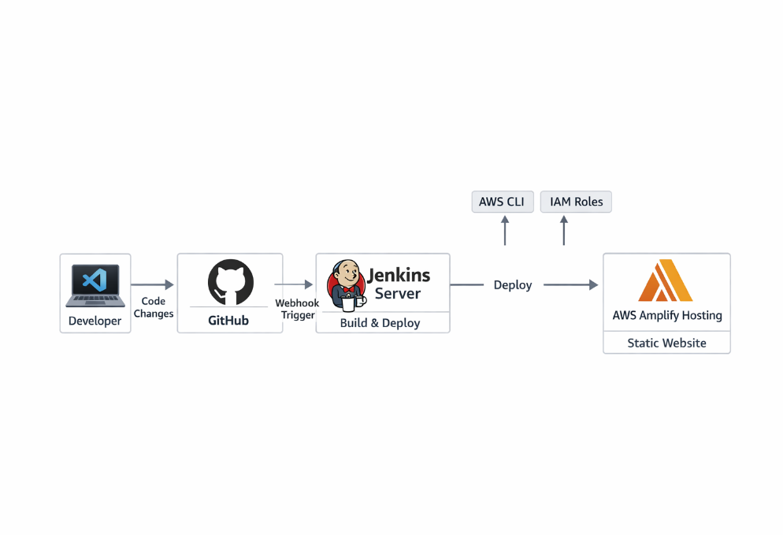
Key Features and Highlights
- Fully Automated CI/CD Pipeline: Eliminates manual deployment steps by automating build and release processes.
- Webhook-Based Triggers: GitHub webhooks ensure real-time deployment on every code push.
- Zero Downtime Deployment: AWS Amplify enables seamless updates without affecting site availability.
- Secure Access Control: IAM roles and Jenkins credentials store ensure secure handling of AWS access.
- Scalable Hosting: Amplify provides scalable infrastructure suitable for production workloads.

Security Best Practices Followed
- IAM permissions were restricted to least privilege where possible
- AWS credentials were securely stored in Jenkins credential manager
- No sensitive information was hardcoded
- Jenkins server access restricted using EC2 security groups

Business Value
This project reflects a production-grade CI/CD system that significantly reduces deployment time, improves release reliability, and minimizes human error. It demonstrates strong alignment with DevOps principles such as automation, continuous delivery, infrastructure-as-code mindset, and security-first design.

Conclusion
The AWS CI/CD Static Website Deployment project highlights my hands-on experience with DevOps automation and AWS cloud services. It demonstrates my ability to design, implement, and secure an end-to-end CI/CD pipeline using industry-standard tools. This project directly supports my profile for roles related to Cloud Engineering, DevOps Engineering, and AWS Solution Architecture, and reflects practical skills applicable to real-world enterprise environments.

